**Practical 9**

**Name: Xiaosheng Liang**

**ID: 15211913**

1. **The problem of program:**

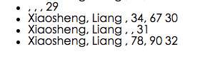

As we see in the picture, if we change the information details by using

“change” page, the previous information is also printed on the last page.

For the same person, what we are supposed to do is *updated the information* not *showed repeatedly*.

**Solution:**

Track the user and update the information by using the id which is used when user enter their name (the first id could be get in the “name” page), therefore the information could be updated not showed repeatedly.

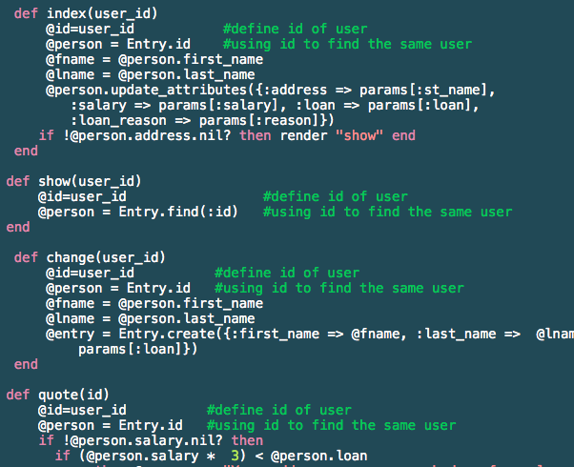

1. **Please follow the following steps:**

* Go to “com” folder (“cd com”), and run the server by “rails server”,
* Open the browser and go to the link “localhost:3000/main/welcome”.
* Click the “GO” button and go to the next page, and click the ”Next Page” to “goodbye” page. Click “Home” button to go back to the first page.

1. **rails_autolink**

Yes, we could use autolink.

* Install the rails_autolink “gem install rails_autolink” (make sure the version of your rails is greater than 3.1)
* Import this gem by “require ‘rails _autolink’”
* Write the link which you want to go to in the program.